Maze
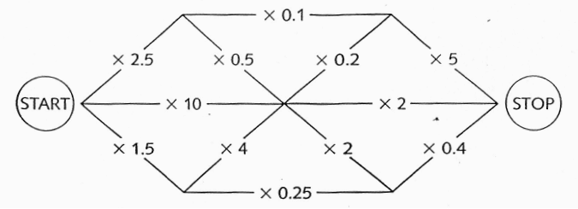
Start with 1 in your calculator display.

Choose a route from START to STOP.
You can travel along each path once.
Multiply the number in your display by the number on the path.
The aim is to finish with 5 in the display.

Products

A game for two players or teams, each with their own coloured pen.
Take turns to choose two of these numbers. -

7 16 27 31 46 56 67 71

Multiply them together. If you can, ring the answer on the grid.

506 | 1426 | 217 | 837 | 1136 | 3266
4757 | 1809 | 1242 | 3082 | 341 | 112
77 | 496 | 3752 | 432 | 176 | 2201
1917 | 736 | 737 | 189 | 2576 | 1072
616 | 322 | 896 | 781 | 3976 | 497
469 | 1512 | 1736 | 2077 | 392 | 297

The winner is the first team with four rings in a line in any direction.

